**Frontend Development with React.js**

**Project Documentation:SS Fitness-Your**

**Personal Fitness Companion**

**1. Introduction:**

**Project Title:**

**SS Fitness: Your Personal Fitness Companion**

**Team Members and Roles:**

**Team Leader**: Suganthiya S

**Email ID**: [sac2225cap45@ssacollegechennai.com](mailto:sac2225cap45@ssacollegechennai.com)

**Team Members:**

* **Sowmiya V**

**Email ID**: [sac2225cap44@ssacollegechennai.com](mailto:sac2225cap44@ssacollegechennai.com)

* **Sowmiya M**

**Email ID**: [sowmiyajona@gmail.com](mailto:sowmiyajona@gmail.com)

* **Sindhuja B**

**Email ID**: [sac2225cap42@ssacollegechennai.com](mailto:sac2225cap42@ssacollegechennai.com)

Here's a Medium-style post for your Fitness app project team:

**Team Collaboration:** Building a Fitness App Together

As we embark on this exciting project to build a Fitness app, I want to acknowledge the incredible team behind it. Our collaboration, creativity, and commitment to delivering a top-notch product will make all the difference.

**Suganthiya S:** Project lead and coordinator, ensuring everything runs smoothly and on track.

**Sowmiya M:** Expertise in UI/UX design, crafting an intuitive and visually appealing user interface.

**Sindhuja B:** Skilled developer, handling the app's backend and ensuring seamless functionality.

**Sowmiya V:**Research and content specialist, curating relevant and engaging digital fitness content for our users.

**2. Project Overview:**

**Purpose of SS Fitness:**   
SS Fitness is a personal fitness companion designed to help users track their workouts, monitor nutrition, and achieve fitness goals through a structured and interactive platform.The app aims to make fitness accessible, enjoyable, and effective for all users, regardless of their experience level.

**Features of SS Fitness:**

1. **User Profile Creation & Customization:**

* Users can create personalized profiles with details such as fitness goals, preferences, and current fitness levels.
* Option to upload photos, track body measurements, and set progress goals.
* **Personalized Workout Plans:**
* Based on the user's profile, the app generates customized workout routines.
* Features different workout types (strength, cardio, flexibility, etc.) with adjustable intensity levels.
* Instructional videos and step-by-step guides for each exercise.

1. **Workout and Progress Sharing:**

* Users can share their workout routines, progress updates, and achievements within the app’s community or on social media platforms.

1. **Search and Filter Functions:**

* Users can filter exercises or workouts by type, duration, or body focus area.
* Easy-to-navigate search bar to find specific workouts, nutrition advice, or other app features.

1. **User-Friendly Interface:**

* Intuitive navigation with clear, responsive design for an engaging user experience.
* Dark and light mode options for accessibility and comfort.

**3. Architecture:**   
SS Fitness is a **React.js-based** frontend application that communicates with a backend API for data persistence and authentication. It follows a **component-driven architecture** with state management handled through **Context API/Redux**. The application is designed to be **scalable and modular**.

* **Frontend (React.js)**
* **Backend (Optional, API-Driven Approach)**
* **Database**
* **Routing (React Router)**
* **Third-Party Integrations**

**Component Structure:**  
The project follows a modular React component structure with reusable UI components, feature-based folders, and a global state management system.

**State Management:**  
Using [Context API / Redux] for global state management to handle user sessions, workout data, and meal plans.

**Routing:**   
Implemented with React Router for navigation between different sections like Home, Dashboard, Workouts, Nutrition, and Profile.

**4. Setup Instructions:**

**Prerequisites:**   
Ensure you have the following installed:

* Node.js (Latest LTS version)
* npm
* Git

**Installation:**

* Clone the repository:

git clone <https://github.com/your-repo/ss-fitness.git>

* Navigate into the project directory:

cd ss-fitness

* Install dependencies:

npm install

* Start the development server:

npm start

**5. Folder Structure:**

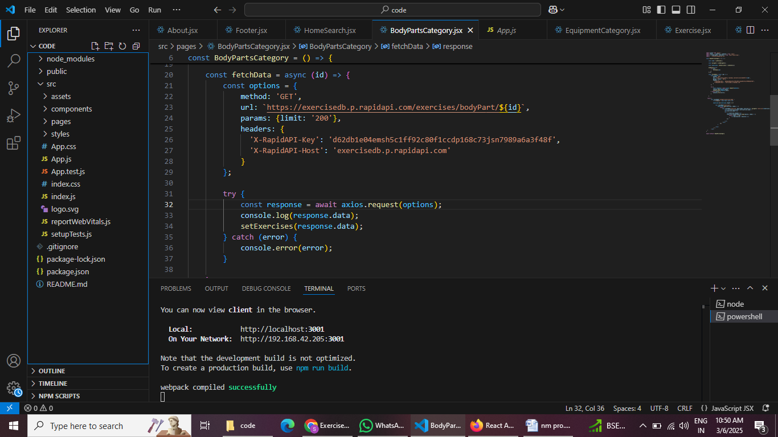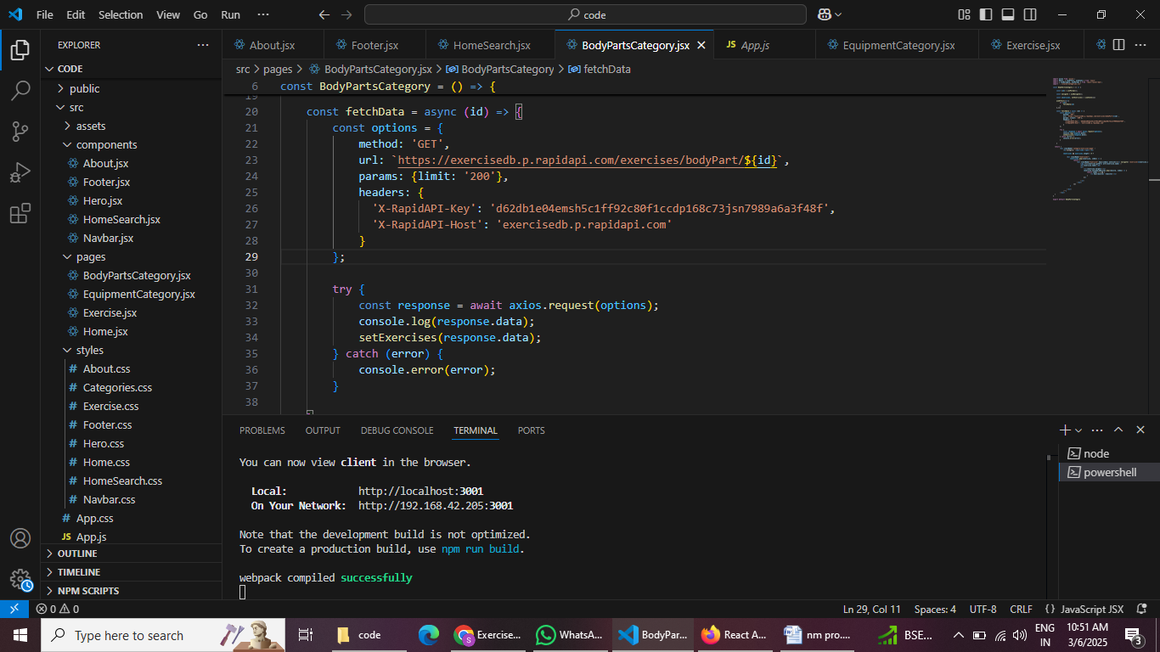

**6. Running the Application:**

To run the project locally, execute:

npm start

**7. Component Documentation:**

**Key Components:**

* WorkoutTracker.js: Tracks user workouts and progress.
* MealPlanner.js: Provides meal plans and nutritional suggestions.
* Dashboard.js: Displays analytics and fitness statistics.
* Profile.js: Manages user information, settings, and progress history.
* ProgressChart.js: Visualizes user fitness progress through graphs.
* ExerciseLibrary.js: Displays a list of exercises with detailed instructions.
* CommunityFeed.js: Allows users to share fitness updates and interact with others.

**Reusable Components:**

* Button.js: Custom button component with different styles.
* Card.js: Generic card component for displaying content.
* Modal.js: Modal for user interactions.
* InputField.js: Standardized input fields for forms.
* Navbar.js: Navigation bar component for seamless user experience.
* Footer.js: Footer section with links and social media integrations.
* LoadingSpinner.js: Displays a loading animation while data is being fetched.
* Notification.js: Provides alerts and notifications for user actions.

**8. State Management:**

**Global State:**  
Uses Context API/Redux to store user data, workout progress, and meal plans.

**Local State:**  
Managed within components using React’s useState and useEffect hooks.

**9.User Interface:**

Include screenshots showcasing different UI features.

**10. Styling:**

**CSS Frameworks/Libraries:**

* Using [Tailwind CSS / Styled-Components / CSS Modules].

**Theming:**

* Custom themes with dark/light mode support.

**11. Testing:**

**Testing Strategy:**

* Unit tests using Jest & React Testing Library.
* End-to-end testing with Cypress.

**Code Coverage:**

* Ensuring test coverage with Jest and coverage reports.

**12. Screenshots or Demo:**

* **Hero component:**

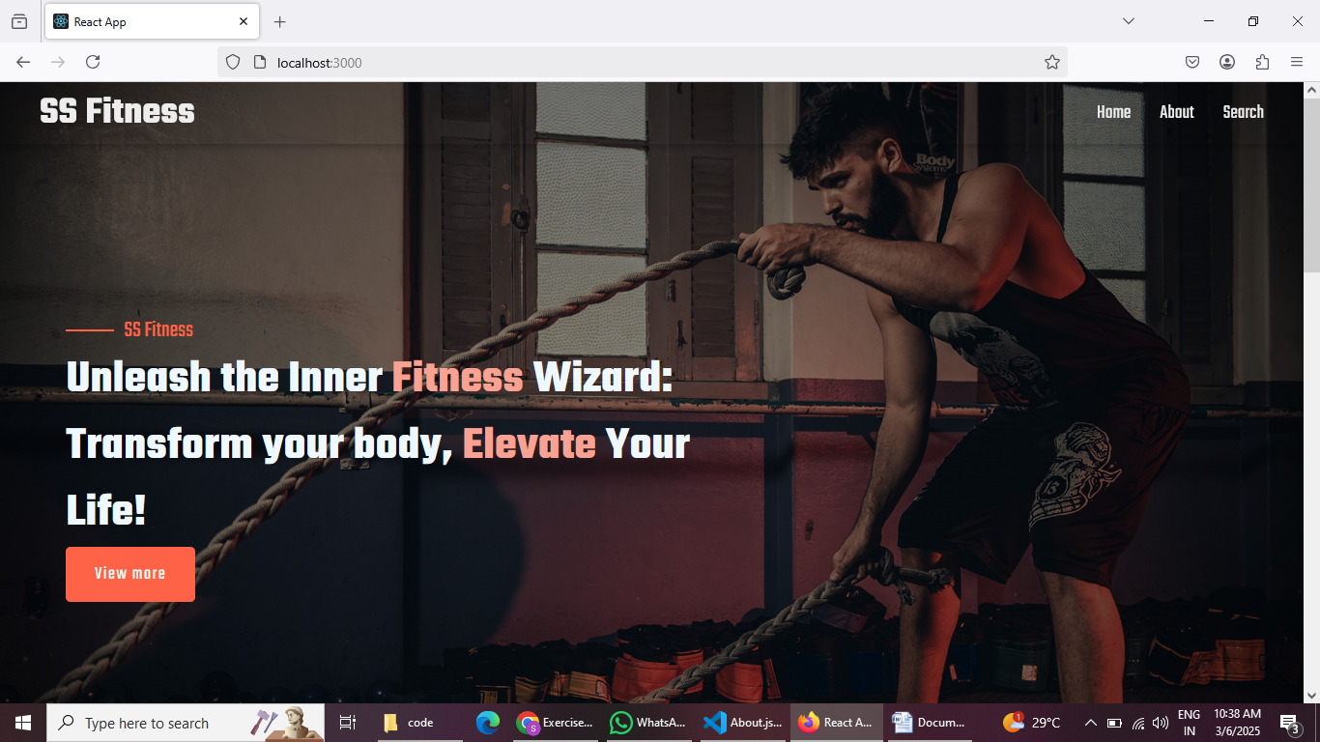 This section would showcase trending workouts or fitness challenges to grab users' attention.

* **About:**

SS Fitness isn't just another fitness app. We're meticulously designed to transform your workout experience, no matter your fitness background or goals.

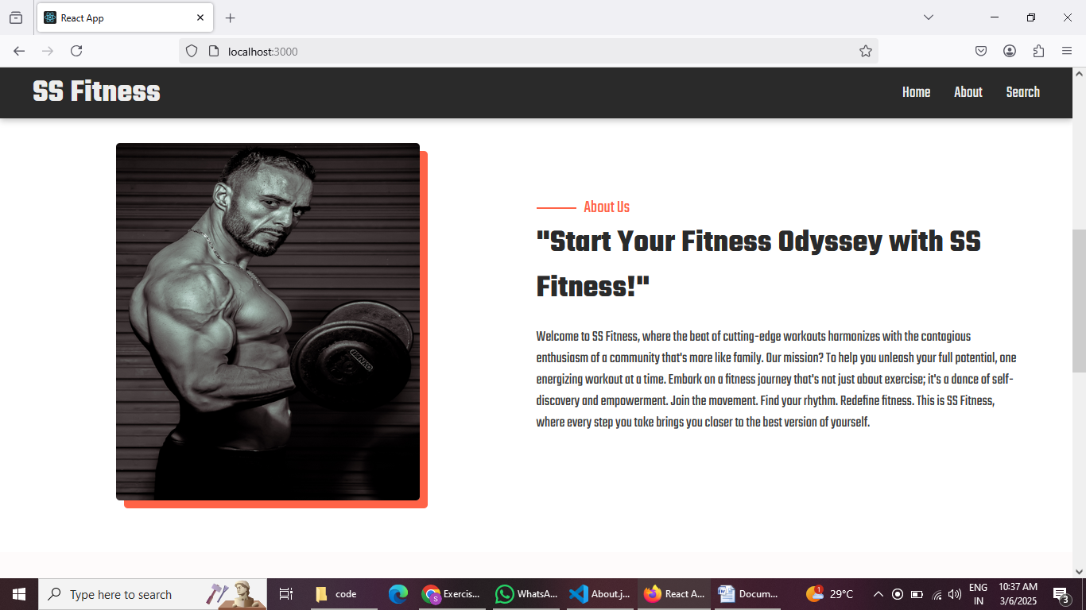

* **Search:**

SS Fitness makes finding your perfect workout effortless. Our prominent search bar empowers you to explore exercises by keyword, targeted muscle group, fitness level, equipment needs, or any other relevant criteria you have in mind. Simply type inyour search term and let SS Fitness guide you to the ideal workout for your goals.

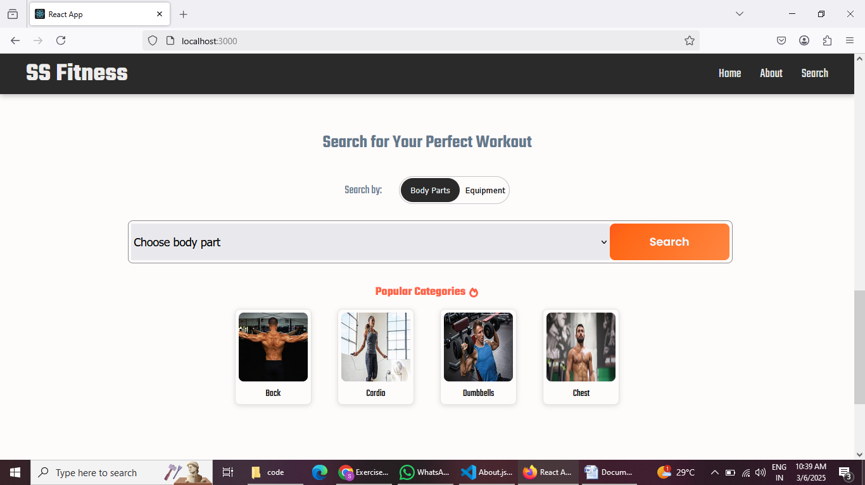

* **Category page:**

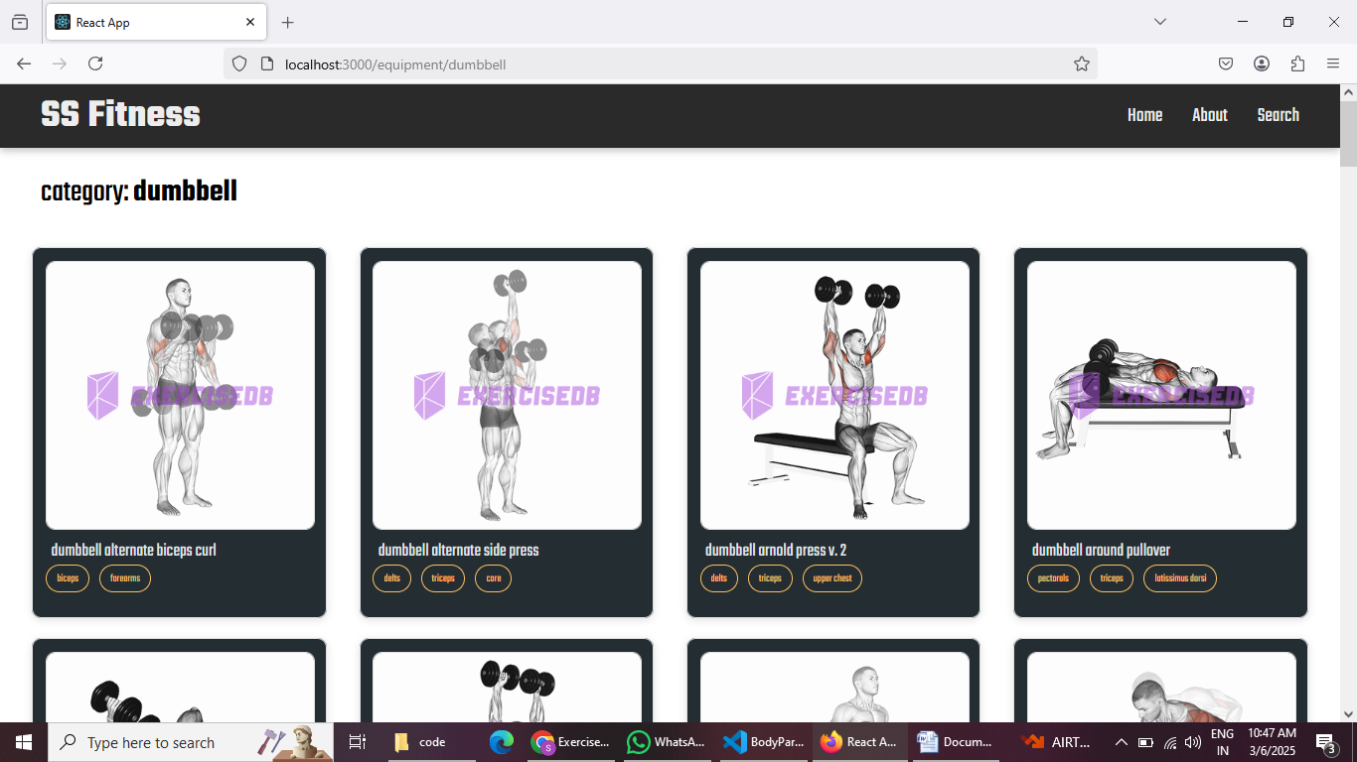SS Fitness would offer a dedicated section for browsing various workout categories. This could be a grid layout with tiles showcasing different exercise types (e.g., cardio, strength training, and yoga) with icons or short descriptions for easy identification.

* **Exercise page :**

This is where the magic happens! Each exercise page on SS Fitness provides a comprehensive overview of the chosen workout. Expect clear and concise instructions, accompanied by high-quality visuals like photos or videos demonstrating proper form. Additional details like targeted muscle groups, difficulty level, and equipment requirements (if any) will ensure you have all the information needed for a safe and effective workout.

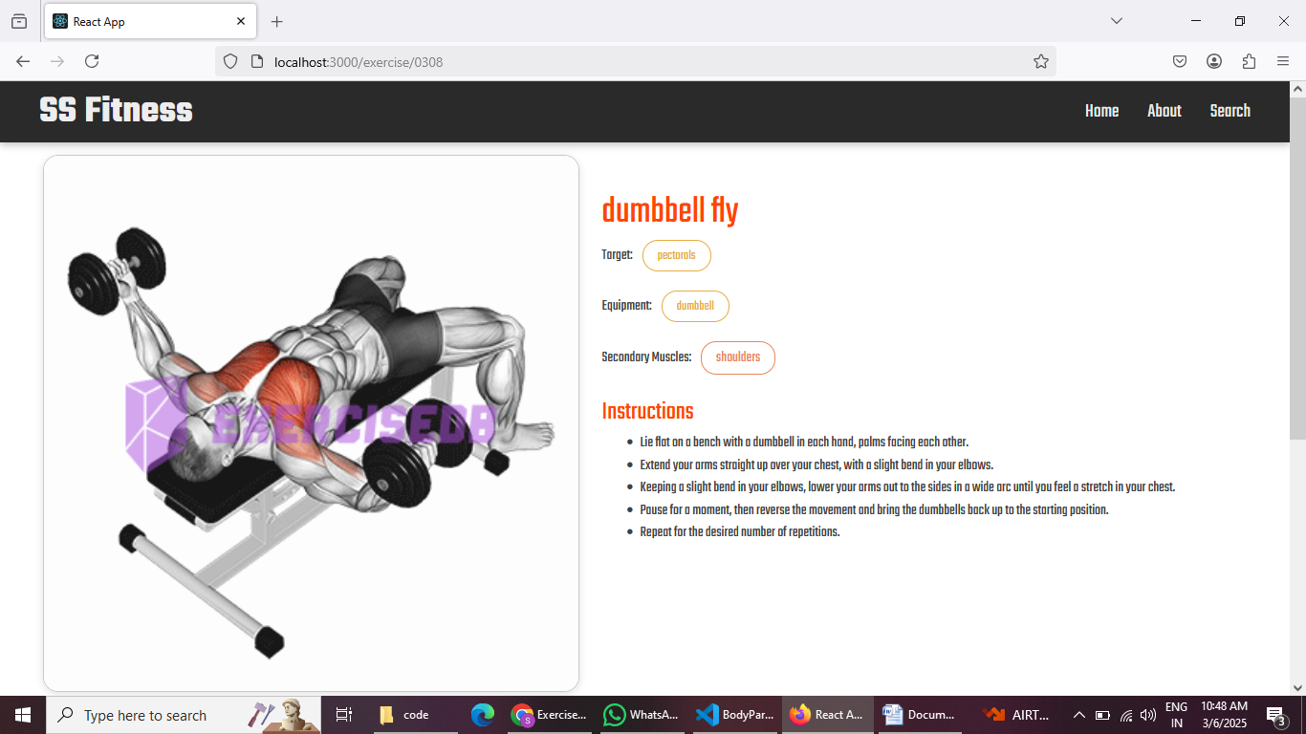

**Demo Video Link:**

<https://drive.google.com/file/d/1Xr_2tM-AzTdET4rW-XsUp0Xfx5MuJEVk/view?usp=drive_link>

**13. Known Issues:**

* Document any known bugs or issues that users or developers should be aware of.
* Some API calls may have rate limits.

**14. Future Enhancements:**

* AI-powered workout suggestions.
* Integration with fitness devices (smartwatches, wearables).
* Gamification features for user engagement.
* Social features like leaderboards and challenges.

**15. Code Repository:**

Use the source code link:

<https://drive.google.com/file/d/1tM834UZF8P6XOeQJWaRtzPF0H5SvySb9/view?usp=drive_link>